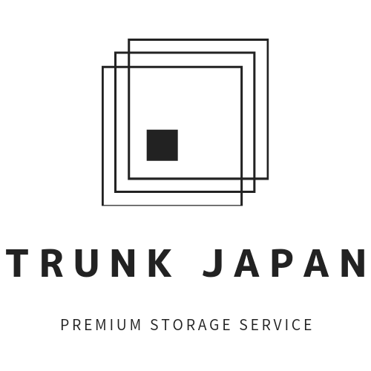
PRESS RELEASE
May 10, 2021
Launching a Premium Storage Service for Yangon ex-pats Returning Home Temporarily
https://zero2onemyanmar.com
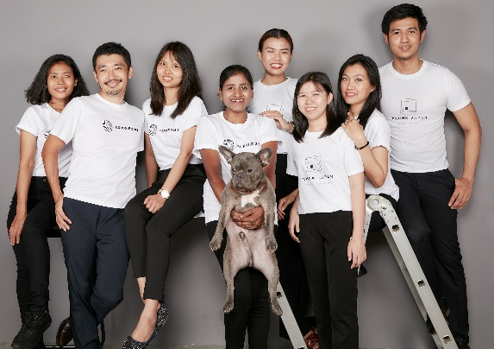

ZERO2ONE COMPANY (Head office: Yangon, Myanmar, CEO: Daiki Kato) has launched TRUNK JAPAN, a premium storage service for ex-pats who were forced to return to their home countries due to various reasons. TRUNK JAPAN provides a one-stop temporary moving and storage service.
TRUNK JAPAN provides a one-stop service from packing, storage, return, and reinstallation on behalf of customers. We can reduce these vast costs and protect customers' belongings from risks such as mold. Our female staff can help packing women's clothing and underwear.
And, we offer a variety of packages based on the circumstances of each customer. In addition, we also purchase and dispose of unwanted furniture and home appliances upon customer request.
TRUNK JAPAN has partnered with Pathway Moving, a US company, and several Japanese companies to provide the highest quality premium storage services.

For more information, please feel free to contact the following;
Website https://zero2onemyanmar.com
Email support@zero2onemyanmar.com
Phone: +95 925556 2071
Address: YAMA Hotel, No.195, Bo Myat Htun Road, 9 Block, Botahtaung Township, Yangon

